INTRODUCTION
Financial decision is one of the integral and important parts of financial management in any kind of business concern. A sound financial decision must consider the board coverage of the financial mix (Capital Structure), total amount of capital (capitalization) and cost of
capital (Ko). Capital structure is one of the significant things for the management, since it influences the debt equity mix of the business concern, which affects the shareholder’s return and risk. Hence, deciding the debt-equity mix plays a major role in the part of the
value of the company and market value of the shares. The debt equity mix of the company can be examined with the help of leverage.
The concept of leverage is discussed in this part. Types and effects of leverage is discussed in the part of EBIT and EPS.

Meaning of Leverage
The term leverage refers to an increased means of accomplishing some purpose. Leverage is used to lifting heavy objects, which may not be otherwise possible. In the financial point of view, leverage refers to furnish the ability to use fixed cost assets or funds to increase the return to its shareholders.

Definition of Leverage
James Horne has defined leverage as, “the employment of an asset or fund for which the firm pays a fixed cost or fixed return.

Types of Leverage
Leverage can be classified into three major headings according to the nature of the finance mix of the company.
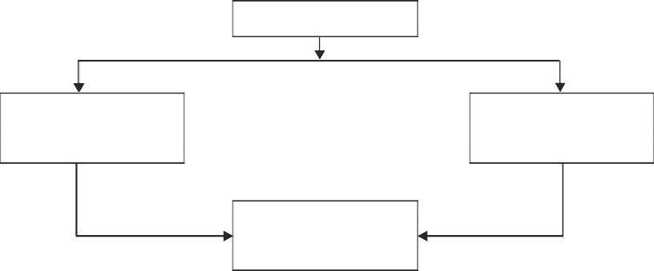
Finacial Leverage
Operating Leverage
Composite Leverage
Leverage
Fig. 7.1 Types of Leverage
The company may use finance or leverage or operating leverage, to increase the EBIT and EPS.

OPERATING LEVERAGE
The leverage associated with investment activities is called as operating leverage. It is caused due to fixed operating expenses in the company. Operating leverage may be defined as the company’s ability to use fixed operating costs to magnify the effects of changes in sales on its earnings before interest and taxes. Operating leverage consists of two important costs viz., fixed cost and variable cost. When the company is said to have a high degree of operating leverage if it employs a great amount of fixed cost and smaller amount of variable cost. Thus, the degree of operating leverage depends upon the amount of various cost structure. Operating leverage can be determined with the help of a break even analysis.
Operating leverage can be calculated with the help of the following formula:
OL = C
OP
Where,
OL = Operating Leverage
C = Contribution
OP = Operating Profits

Degree of Operating Leverage
The degree of operating leverage may be defined as percentage change in the profits resulting from a percentage change in the sales. It can be calculated with the help of the following formula:
DOL = Percentage change in profits/ Percentage change in sale

Exercise 1
From the following selected operating data, determine the degree of operating leverage.
Which company has the greater amount of business risk? Why?

 | Company A Rs. | Company B Rs.
Sales | 25,00,000 | 30,00,000
Fixed costs | 7,50,000 | 15,00,000
Variable expenses as a percentage of sales are 50% for company A and 25% for company B.

Solution
Statement of Profit

 | Company A  Rs. | Company B  Rs.
Sales | 25,00,000 | 30,00,000
Variable cost | 12,50,000 | 7,50,000
Contribution | 12,50,000 | 22,50,000
Fixed cost | 7,50,000 | 15,00,000
Operating Profit | 5,00,000 | 7,50,000

Operating Leverage = Contribution
Operating Profit

“A” Company Leverage = “B” Company Leverage =

Comments

12,50,000
5,00,000 = 2.5
2,25,000

7,50,000 = 3

Operating leverage for B Company is higher than that of A Company; B Company has a higher degree of operating risk. The tendency of operating profit may vary portionately with sales, is higher for B Company as compared to A Company.

Uses of Operating Leverage
Operating leverage is one of the techniques to measure the impact of changes in sales which lead for change in the profits of the company.
If any change in the sales, it will lead to corresponding changes in profit. Operating leverage helps to identify the position of fixed cost and variable cost.
Operating leverage measures the relationship between the sales and revenue of the company during a particular period.
Operating leverage helps to understand the level of fixed cost which is invested in the operating expenses of business activities.
Operating leverage describes the over all position of the fixed operating cost.

